Irregular Past Participle and Simple Past, Present Perfect, Present Perfect Progressive

Student Profile
Students are studying at Thompson Rivers University and they range in age and country of origin. For this class, these students are in an intermediate level grammar lab. The grammar lab is taught two days after the instructional class and is used for the purpose of review.

Introduction and Objectives (2mins)
- Students will work on recognizing and memorizing the past participles and simple past tenses of irregular verbs through various activities.
- Students will continue to review simple past and present perfect verb tenses while creating their own sentences.
- Students will begin to use present perfect progressive in sentences.

Activity 1: Matching and Fill In The Blank (10mins)
- 1. Matching Game:
  - There will be three columns with irregular verbs under each category (Simple Form, Simple Past, Past Participle)
  - Students will draw lines using the interactive whiteboard to match the correct pairs

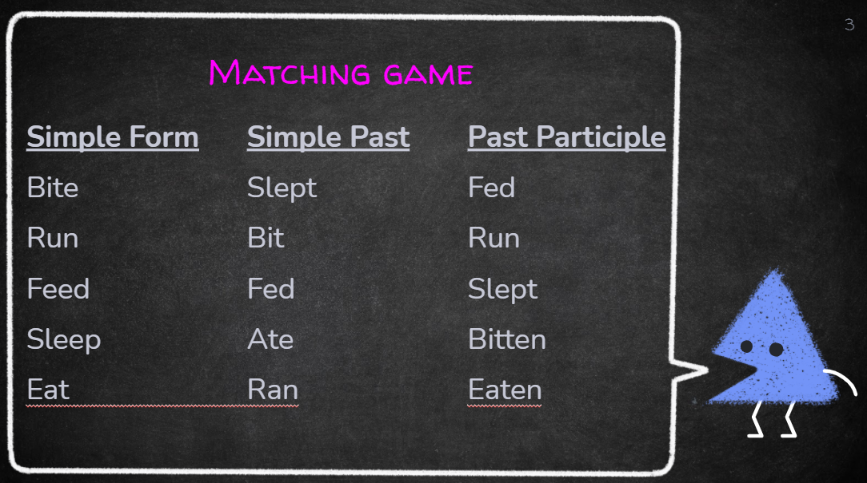

- 2. Fill in the blank
  - There will be three columns with irregular verbs under each category (Simple Form, Simple Past, Past Participle)
  - There will be blanks in the chart and students will figure out what’s missing (figure out the correct conjugation of each irregular verb)

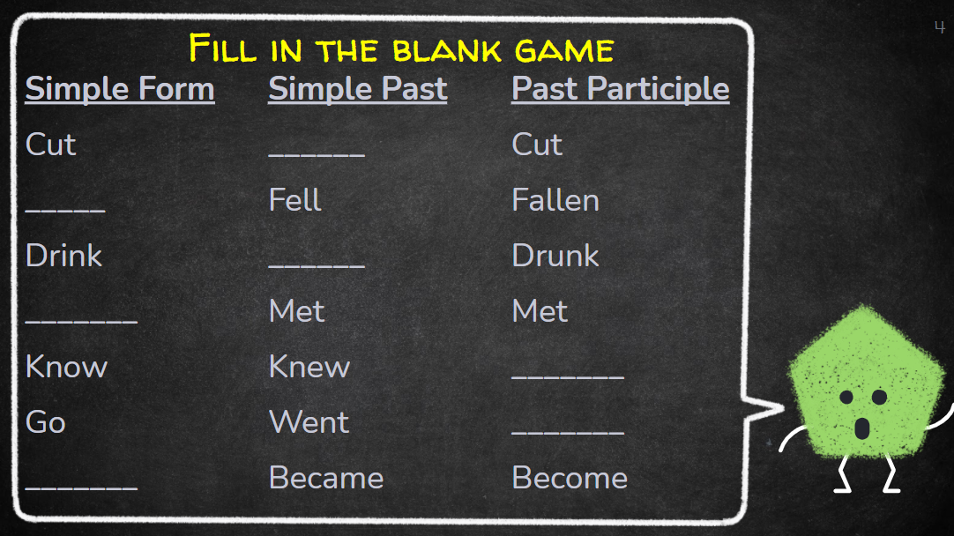

Activity 2: Concentration Game – (10min)
- Students will have to concentrate and memorize the placement of cards to match pairs. They will need to choose 1 card and find its conjugated form. Game will be played via screenshare of an online platform. We will play this game twice, once covering infinitive → simple past and once covering infinitive → Past Participle

Concentration game platform: https://www.educandy.com/site/index.php

Activity 3: Breakout Rooms review of simple past and present perfect (15mins)
Students will be given a topic.
- Separate into breakout rooms (3-4 students)
- Students will have to create sentences about the topic using simple past and present perfect tenses
- Students will need to copy&paste sentences to shared notes in main class
- Group with most correct sentences get 1 point
- Repeat this twice, first time 5mins and 2nd time 5mins
Two topics: Dinner and University. Mock round topic is Pets.

Simple past:
I had a cat.
Yesterday, I bought a new fish.

Present perfect:
She has walked her dog.
They have wanted a dog for a long time.

Activity 4: Exit ticket (10mins)
1. Questions for students to answer in chatbox:
- What ‘ending’ is used to make a word progressive? = ing
- What is the present perfect structure? = have/has + past participle
- What do you think is the structure of the Present Perfect Progressive? = has/have + been + ___ing
2. Then write with interactive whiteboard the present perfect progressive structure and give some examples.

(examples)

An action that started in the past, and continued up until the present:
- The cat has been hiding under the couch for over an hour now.
- Sam has been working as a teacher since she graduated.
- They have been chatting for the last two hours.
- I have been working for you for the last three months.

To show something was happening lately/recently:
- Lately, Susan has been coming late.
- I haven't been studying much recently.
- The kids have been watching too much TV lately.

3. Flip to the next slide. There is a list of sentences already created. Each student will be asked to fill in one of the sentences either by typing in chat box or coming on the mic (we will encourage more mic use for this one).

I have been _____-ing for the last 10 minutes.
I have been ____-ing since January.
I have been _____-ing since Friday.
I have been _____-ing for the last three months.
I have been ____-ing for the last 5 hours.
I have been _____-ing for over 2 hours now.

Thank you & Goodbye (2mins)

