Past Perfect Progressive, Simple Future, Modal Verbs

Student Profile
Students are studying at Thompson Rivers University and they range in age and country of origin. For this class, these students are in an intermediate level grammar lab. The grammar lab is taught two days after the instructional class and is used for the purpose of review.

Introduction and Objectives (2 minutes)
- Students will practice creating sentences using the past perfect progressive tense.
- Students will be introduced to the simple future tense and be able to recognize the different uses of this verb tense.
- Students will be listening to find missing words to a song and identify what verb tense is used in that sentence.

Activity 1 - Create sentences in Past Perfect Progressive (7 minutes)
- Ask students if they know the structure for the past perfect progressive, type in chat box.
- Then write structure with the interactive whiteboard on the slide and explain how it is used.
- Then ask students to go into shared notes. They will find a sentence starter - they need to create as many sentences from the starter as possible using the image on the screen.

Sentence starters:
- He was exhausted because ….
- They were excited because ….
- She had a lot of energy because ….

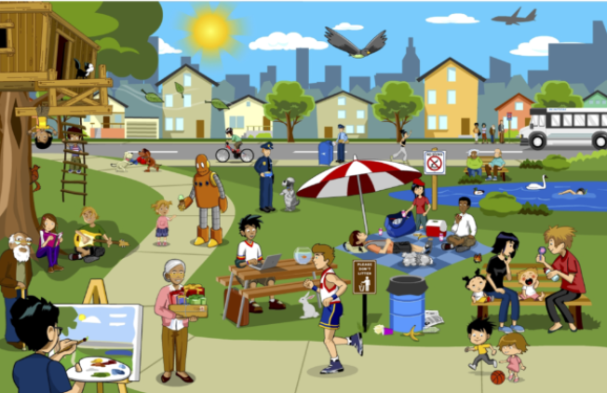

Activity 2 - Image Prediction (7 minutes)
- Introduce students to the Simple Future tense. Ask them what the 2 mains ways are this tense is expressed (type in chat).
- Use interactive whiteboard to write the structures for simple future tense on the board.
- Next slides have images on them. Ask students to type in chat and predict what will happen 1 second after the image is captured. Students will need to use the simple future tense.

Images:
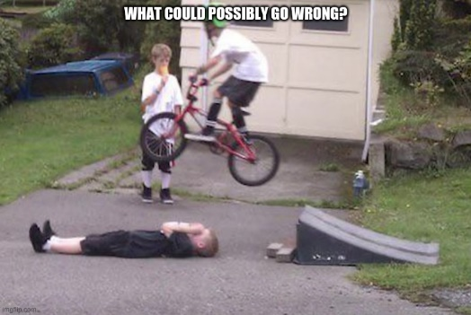

Activity 3 - Simple Future (7 minutes)
Prediction Vs Prior Plan Vs Willingness
We will ask students some questions to review the use of will and going to in the simple future tense.

Match using interactive whiteboard
- Which sentence expresses a prior plan? ___
- Which sentences are predictions? ___ and ___
- Which sentence expresses an offer to help? ___

- I’m going to see my friend Isa tomorrow.
- Don’t worry. I’ll drive him to school on Friday.
- It is going to be sunny tomorrow.
- I think you’ll have fun.

Poll (Vote A=Prediction, B=Plan, C= Willingness)
- This is spicy! I’m going to have a stomach ache tomorrow. (A)
- That’s not good, you have a presentation tomorrow. I’ll go buy some pepto-bismol. (C)
- I am definitely not going to eat this next time. (B)

Activity 4 - Songs in breakout rooms (25 minutes - 10 as a class, 10 in breakout rooms, 5 to come back and check answers and identify verb tenses used)

The Lumineers - Ho Hey (together in class) [1:45s]
- The lyrics of the song will be posted in shared notes (with blanks)
- Students listen to the song and fill in the blanks.
- We will then go over the lyrics as a class and identify which verb tenses are used.
- We will also ask students if there are any new words or phrases that they would like us to explain.

“Ive been tryin' to do it right [pres perf prog]  (Hey) Ive been livin' a lonely life  (Ho) Ive been sleepin' here instead [pres perf prog]  (Hey) Ive been sleepin' in my bed  (Ho) Ive been sleepin' in my bed [pres perf prog]  (Hey)  (Ho)  (Ho) so show me family  (Hey) all the blood that I will bleed [simple fut]  (Ho) I don't know where I belong  (Hey) I don't know where I went wrong [simple past]  (Ho) but I can write a song  (Hey)  I belong with you, you belong with me  You're my sweetheart  I belong with you, you belong with me  You're my sweet [simple present]  come on, now  (Ho) hey  (Hey)  I don't think you're right for him  (Hey) think of what it might've been if we [modal + have + past participle]  (Ho) took a bus to Chinatown [simple past]  (Hey) I'd be standin' on Canal  (Ho) and Bowery  (Hey)  (Ho) she'd be standin' next to me  (Hey) | “I’ve been __1___ to do it right  (Hey) I’ve been living a lonely life.  (Ho) I’ve __2__ sleeping here instead  (Hey) I’ve been sleeping' in my bed  (Ho) I’ve _3__ __4__in my bed  (Hey)  (Ho)  (Ho) so show me family  (Hey) all the blood that I __5__ bleed  (Ho) I don't know where I belong  (Hey) I don’t know where I __6__ wrong  (Ho) but I __7____ write a song  (Hey)  I belong with you, you belong with me  You're my sweetheart  I belong with you, you belong with me  ___8___ my sweet  come on, now  (Ho) hey  (Hey)  I don't think you're right for him  (Hey) think of what it ___9___ been if we  (Ho) ___10___ a bus to Chinatown  (Hey) I'd be standing on Canal  (Ho) and Bowery  (Hey)  (Ho) she'd be standing next to me  (Hey)

- "Might" is a modal verb commonly used to express possibility, make suggestions and requests.

Whitney Houston - I will always love you (in breakout rooms) [3:05s]
- Split students into breakout rooms
- Students will need to upload the video and work in small groups to fill in the blanks.
- After, we will then go over the lyrics as a class and identify which verb tenses are used.
- We will also ask students if there are any new words or phrases that they would like us to explain.

If I should stay [modal verb]  I would only be in your way [modal verb]  So I'll go, but I know [simple future]  I'll think of you every step of the way  And I will always love you [simple future]  I will always love you  You, my darling, you, hmm  Bittersweet memories  That is all I'm taking with me [present progressive]  So, goodbye  Please, don't cry  We both know I'm not what you, you need  And I will always love you [simple future]  I will always love you  [instrumental break]  I hope life treats you kind  And I hope you have all you've dreamed of [present perfect]  And I wish to you joy and happiness  But above all this, I wish you love [wish = simple present verb, but expresses future desire]  And I will always love you  I will always love you… | If I __1___ stay  I __2___ only be in your way  So __3__ __4__, but I know  I'll think of you every step of the way  And I ___5___ always love you  I will always love you  You, my darling, you, hmm  Bittersweet memories  That is all I'm __6___ with me  So, goodbye  Please, don't cry  We both know I'm not what you, you need  And I __7__always love you  I will always love you  [instrumental break]  I hope life treats you kind  And I hope you have all __8__ __9___ of  And I wish to you joy and happiness  But above all this, I __10__ you love  And I will always love you  I will always love you…

- Should/Would = We use should mainly to: give advice or make recommendations. talk about obligation. talk about probability and expectation.
We use would mainly to: talk about the past. talk about the future in the past. express the conditional mood.

Thank you & Goodbye (2min)

