Semester Review - Grammar

Student Profile
Students are studying at Thompson Rivers University and they range in age and country of origin. For this class, these students are in an intermediate level grammar lab. The grammar lab is taught two days after the instructional class and is used for the purpose of review.

Objectives/Learning Outcomes
- Students will review everything they have covered in the textbook through various activities.
- Students will practice using modals through a quick activity in breakout rooms to understand how it is used to give advice or suggestions.

Warm-up Activity (10 mins)
We will ask students to vote whether they want to review previous content through a matching activity or multiple-choice questions. We will use the interactive whiteboard to give answers. This review will include past participle, stative verbs, irregular verbs, past perfect progressive.

Matching (SAM)
1. Match infinitive > Simple Past > Past Participle
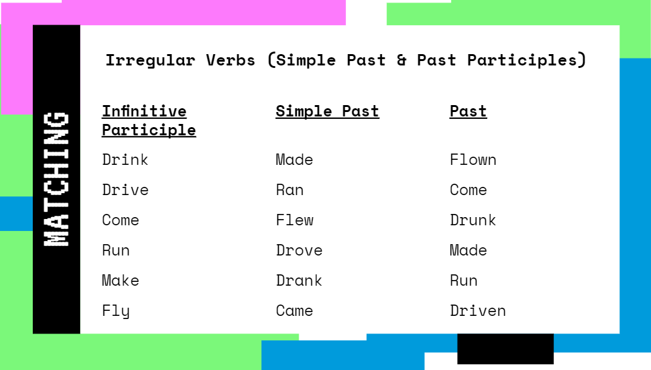
2. Match to: Stative or Action (Dynamic)
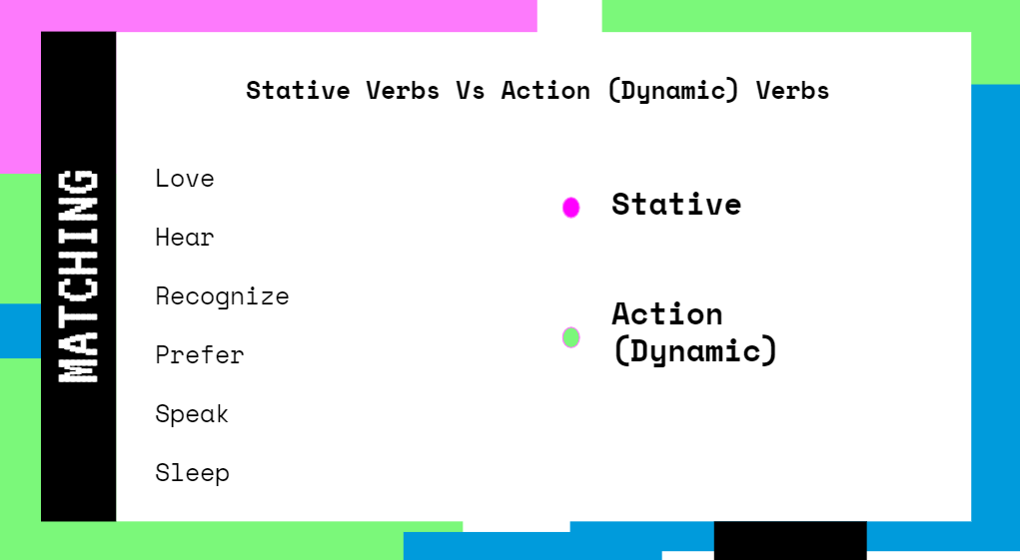

3. Match Sentence to Verb Tense

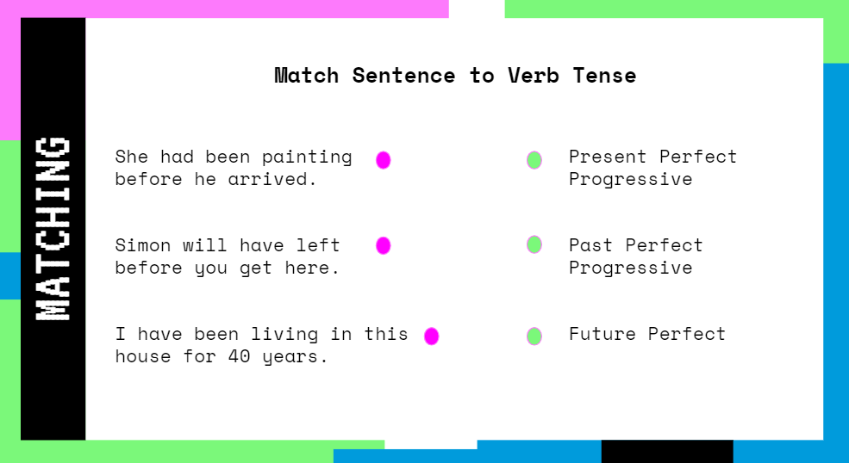
Multiple Choice
- Today the students are sharing food. Martin is preparing Biryani for the class and Linh is bringing Pho. I know today will be a good day! Which verb is the stative verb?
    - Sharing
    - Preparing
    - Bringing
    - Know
- Jihoon and Evan were sitting outside thinking about the final exam. Amy sat beside them and happily shouted “the final exam is cancelled!” Jihoon and Evan were shocked! Then Amy started to laugh and said “just kidding!”. Which verb is a stative verb?
    - Thinking
    - Shouted
    - Sitting
    - Started
- In the correct order, which is the simple form, simple past, and past participle? (wear, wore, worn / wear, worn, wore)
- Which are all correct past participles? (hidden, taken, bent / shut, forget, drunk / left, lose, paid)
- Present Perfect is used where there is a specific mention of time? (Y/N- that’s simple past)
- Which sentence is an example of past perfect progressive?
    - By the time Fabi found an umbrella, it had been raining for 10 minutes.
    - It had been raining for 10 minutes by the time Fabi found an umbrella.
    - It had rained for 10 minutes by the time Fabi found an umbrella.
    - Both (a) and (b)

Activity 1: General Review - Sentence Giving (15mins)
We will split class into group A and group B. Each student in each group will see their name on the board plus different verb tenses. We will ask each student to use the interactive whiteboard and create a sentence under any verb tense they wish. Each student will then need to come on the mic and share their sentence with the class.
Group A: Simple Past, Present Perfect, Present Perfect Progressive, Past Perfect, Simple Future, Future Progressive
Group B: Simple Present, Present Progressive, Simple Past, Past Progressive, Simple Future, Modal a

Activity 2: What’s your problem right now? (Modal Practice) (20mins, breakout for 7-10mins)
Ask students to type in shared notes a problem they are having right now. We will choose as a class four problems to solve. Assign a different problem to each of the groups (groups will be preassigned). When all students know which one to try and solve, they will be placed in breakout rooms. Students will use modals to make suggestions or give advice to solve the problem. They are to then copy and paste the solutions and share once they are back in the main room (One person from each room must come on the mic and share).

Final Goodbye & Thank you

